City of South Perth Historical Society (Incorporated)

# PHILLIP PENDAL YOUNG HERITAGE AWARD



Entry Form

First Name:

Surname:

Email Address:

Home Address:

Mobile Phone Contact:

Parent/Guardian Name:

Teacher’s Name:

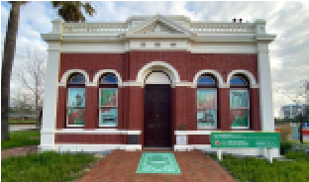

School:

Year Division:

Year at School: Title of Entry:

I declare this entry is my own work. (student to sign)

ONE Photograph, Essay and Bibliography attached.

(student to sign)

I declare this student is eligible to enter the Phillip Pendal Young Heritage Award 2024.

(Parent, Teacher or Guardian to sign)

Entries must be received by midnight on Sunday 27th July 2025

For full terms and conditions, please refer to the City of South Perth Historical Society website. www.southperthhistoricalsociety.org

Enquiries may be emailed to the City of South Perth Historical Society by putting 2024 PPYHA in the subject line: info@southperthhistoricalsociety.org

City of South Perth Historical Society (Inc).

Gallery and Cultural Centre, Heritage House | 111 Mill Point Rd, South Perth, WA 6151

Ph: 9367 9243 | www.southperthhistoricalsociety.org | info@southperthhistoricalsociety.org